BAZIL UDDIN KHAN
24K-0559
BSCS-3H

TASK#1).
CODE:
Include irvine32.inc

.data
A WORD 45
B WORD 20
Msg1 BYTE " AX VALUE IS : ",0
Msg2 BYTE " BX VALUE IS : ",0

.code
main PROC

mov ax,A
mov bx,B

cmp ax,bx
jz equal_case
jc less_case
jmp greater_case

equal_case:
mov dx, 0
mov cx, ax
mov bx, 2
div bx
mov bx, ax
mov ax, cx
jmp lprint

less_case :
add ax,bx
jmp lprint

greater_case :
sub ax,bx
jmp lprint

lprint :
mov edx,OFFSET Msg1
call WriteString
movzx eax,ax
call WriteInt
call crlf

mov edx,OFFSET Msg2
call WriteString
movzx eax,bx
call WriteInt
jmp Lexit

Lexit:
exit

main ENDP
END main

OUTPUT:
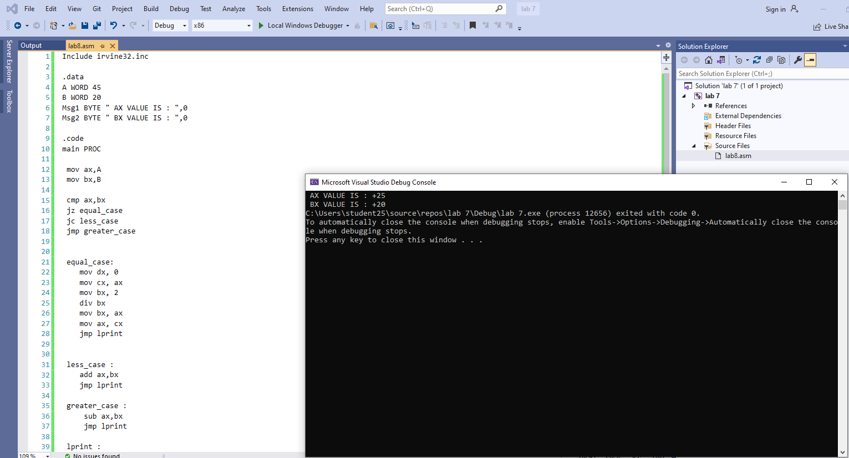

TASK#2).
CODE:
Include irvine32.inc

.data
intArr SWORD 0,0,0,150,120,35,-12,66,4, 0
Temp SWORD 0

.code
main PROC

mov ecx,10
mov esi,OFFSET intArr

loopg:
mov ax,[esi]

cmp ax,0
mov Temp,ax

jnz First_non_zero

add esi,2

loop loopg

jmp Lexit

First_non_zero :

movsx eax,Temp
call WriteInt
jmp Lexit

Lexit:
exit

main ENDP
END main

OUTPUT:
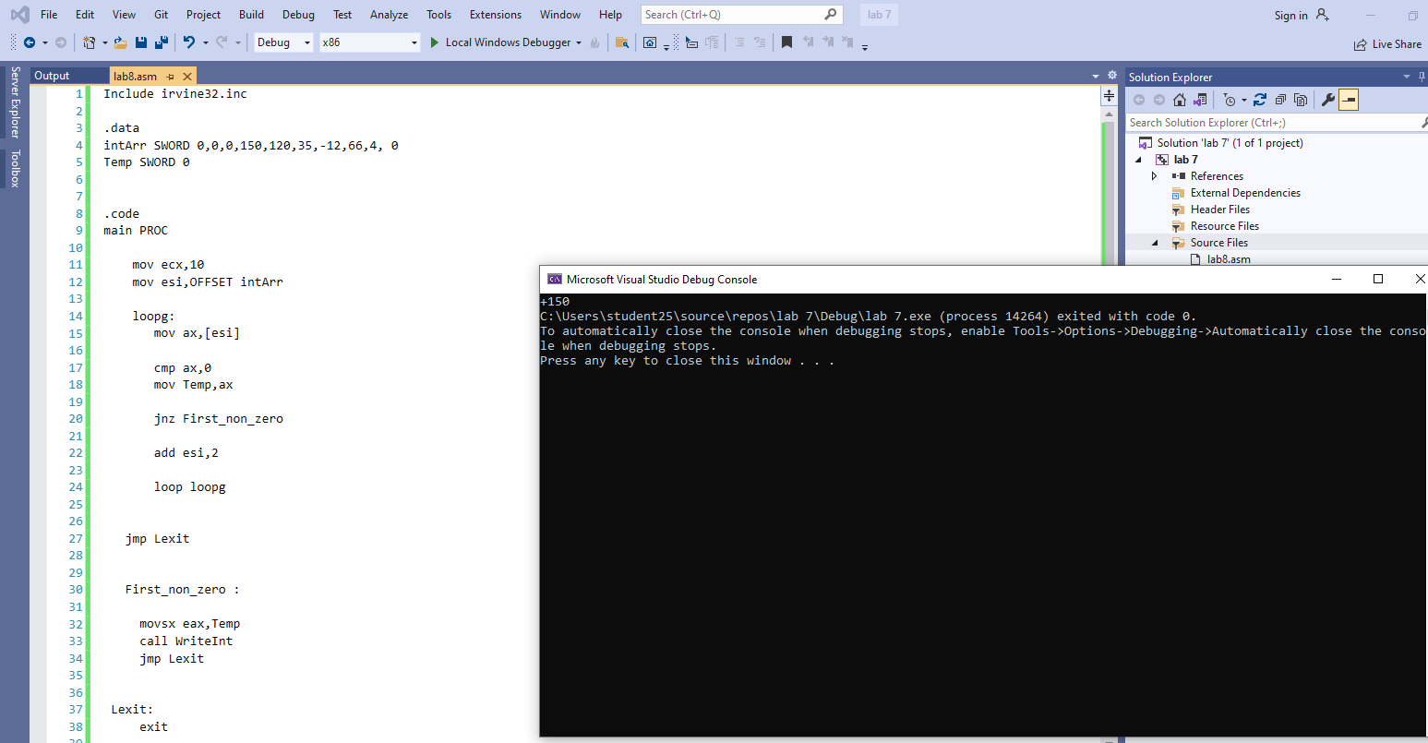

TASK#3).
CODE:
Include irvine32.inc

.data
arr WORD 10,4,7,14,299,156,3,19,29,300,20
Number WORD 0
Msg1 BYTE " Number is Found :",0
Msg2 BYTE " Number is Not Found :",0
Msg3 BYTE " Enter Number :",0

.code
main PROC

mov ecx,11
mov esi,OFFSET arr
mov eax,0

mov edx,OFFSET Msg3
call WriteString

call ReadInt
mov Number,ax

loopsearch :
mov ebx,[esi]
cmp bx,Number
jz L_FOUND

add esi,2

loop loopsearch

L_NOTFOUND :

mov edx,OFFSET Msg2
call WriteString

movzx eax,Number
call WriteInt
jmp lexit

L_FOUND :

mov edx,OFFSET Msg1
call WriteString

movzx eax,Number
call WriteInt
jmp lexit

lexit :
exit

main ENDP
END main

OUTPUT:
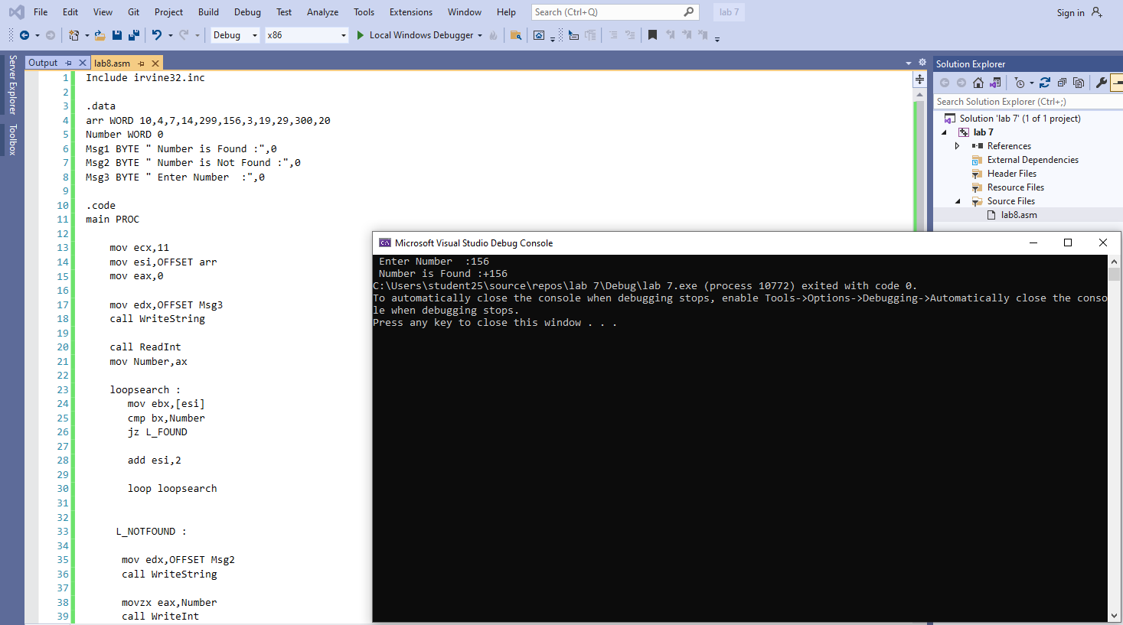

TASK#4).
CODE:
Include irvine32.inc

.data
Msg1 BYTE " Monday ",0
Msg2 BYTE " Tuesday ",0
Msg3 BYTE " Wednesday ",0
Msg4 BYTE " Thursday ",0
Msg5 BYTE " Friday ",0
Msg6 BYTE " Saturday ",0
Msg7 BYTE " Sunday ",0
Msg8 BYTE " Enter Week Number Between 1 till 7 :",0
Msg9 BYTE " Number Not In Weekend Days",0
Daynumber Dword 0

.code
main PROC

mov edx,OFFSET Msg8
call WriteString

mov eax,0
call ReadInt

mov Daynumber,eax

cmp Daynumber,1
jnz Day2
mov edx,OFFSET Msg1
call WriteString
jmp lexit

Day2 :
cmp Daynumber,2
jnz Day3
mov edx,OFFSET Msg2
call WriteString
jmp lexit

Day3 :
cmp Daynumber,3
jnz Day4
mov edx,OFFSET Msg3
call WriteString
jmp lexit

Day4 :
cmp Daynumber,4
jnz Day5
mov edx,OFFSET Msg4
call WriteString
jmp lexit

Day5 :
cmp Daynumber,5
jnz Day6
mov edx,OFFSET Msg5
call WriteString
jmp lexit

Day6 :
cmp Daynumber,6
jnz Day7
mov edx,OFFSET Msg6
call WriteString
jmp lexit

Day7 :
cmp Daynumber,7
jnz NotInlist
mov edx,OFFSET Msg7
call WriteString
jmp lexit

NotInList :
mov edx,OFFSET Msg9
call WriteString
jmp lexit

lexit :
exit

main ENDP
END main

OUTPUT:
